**Final Year B. Tech. (CSE) – I : 2021-22**

**4CS462 : PE2 - Data Mining Lab**

**Assignment No. 1**

**Group id: DM21G12**

**Group members:**

**Abhishek More(2018BTECS00037)**

**Sushil Wagh(2018BTECS00031)**

**Title :** TensorFlow python module

**Objective/Aim :** To study Tensorflow python module

**Introduction:**

TensorFlow is one of the famous deep learning frameworks, developed by Google Brain Team. It is a free and open source software library and designed in the Python programming language. It is entirely based on the Python programming language and used for numerical computation and data flow, which makes machine learning faster and easier.

**Theory/Algorithms:**

* Components of TensorFlow

1. Graphs: TensorFlow makes use of a graph framework. The chart gathers and describes all the computations done during the training.
2. Tensor: The name TensorFlow is derived from its core framework, "Tensor." A tensor is a vector or a matrix of n-dimensional that represents all type of data. All values in a tensor hold similar data type with a known shape. The shape of the data is the dimension of the matrix or an array.

A tensor can be generated from the input data or the result of a computation. In TensorFlow, all operations are conducted inside a graph. The group is a set of calculation that takes place successively. Each transaction is called an op node are connected.

1. Session: A session can execute the operation from the graph. To feed the graph with the value of a tensor, we need to open a session. Inside a session, we must run an operator to create an output.

* Why is TensorFlow popular?

TensorFlow is the better library for all because it is accessible to everyone. TensorFlow library integrates different API to create a scale deep learning architecture like CNN (Convolutional Neural Network) or RNN (Recurrent Neural Network).

TensorFlow is based on graph computation; it can allow the developer to create the construction of the neural network with Tensorboard. This tool helps debug our program. It runs on CPU (Central Processing Unit) and GPU (Graphical Processing Unit).

**Documentation:**

In TensorFlow, a tensor is the collection of feature vector (Like, array) of n-dimension. For instance, if we have any 2x3 matrix with values 1 to 6, we write:

TensorFlow Basics

TensorFlow represents this matrix as:

1. [[1, 3, 5],
2. [2, 4, 6]]

If we create any three-dimensional matrix with values 1 to 8, we have:

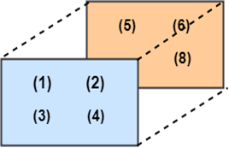

TensorFlow represents this matrix as:

[ [ [1, 2], [3, 4] ], [ [5, 6], [7, 8] ] ]

### 

### Types of Tensor

All computations pass through one or more Tensors in TensorFlow. A tensor is an object which has three properties which are as follows:

* A unique label (name)
* A dimension (shape)
* A data type (dtype)

Each operation we will TensorFlow involves the manipulation of a tensor. There are four main tensors we can create:

* tf.Variable
* tf.constant
* tf.placeholder
* tf.SparseTensor

### Create a tensor of n-dimension

We begin with the creation of a tensor with one dimension, namely a scalar.

**To create a tensor, we can use tf.constant ()**

1. tf.constant(value, dtype, name = "")
2. arguments
3. `Value`: It is the Value of n dimension to define the tensor. And it is Optional.
4. `dtype`: Define the type of data:
5. `tf.string`: String variable
6. `tf.float32`: Float variable
7. `tf.int16`: Integer variable
8. "name": Name of the tensor. Optional. By default, `Const_1:0`

To create a tensor of dimension 0, We have to run below code.

1. ## rank 0
2. ## Default name
3. r1=tf.constant (1, tf.int18)
4. print (r1)

**Output:**

Tensor ("Const: 0", shape= (), dtype=int18

tf.constant() => converts given data into constant tensors for numerical operations

tf.compat.v1.Session() => returns an instance of session for allowing execution of numerical operations

sess.close() => terminates the session

tf.matmul() => performs multiplication on provided tensors

tf.add() => performs addition operation on given tensors

**Procedure:**

As tensorflow is inherently not compatible with Windows operating system. We have used Anaconda Distribution.

# Installation of TensorFlow through conda

In our previous tutorial of TensorFlow, we learn how to install TensorFlow through pip. In this tutorial, we understand that how to install TensorFlow through Conda. Here, we need anaconda Navigator to set-up the platform.

**These are the following steps which are given below:**

Firstly, we have to open the official site of Anaconda and download Anaconda from the below link: <https://www.anaconda.com/distribution/>



After that, we have to download Anaconda from below highlighted Python 2.7 version.

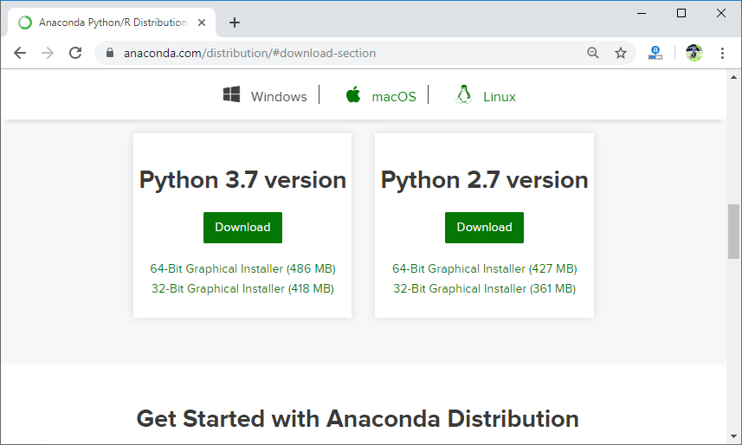

It will successfully be downloaded in our system. After that, we have to install **Anaconda** in our system.



Click on "**Next**."



Click on "**I Agree**."



Again click on "**Next**."



Click on "**Next**" again.

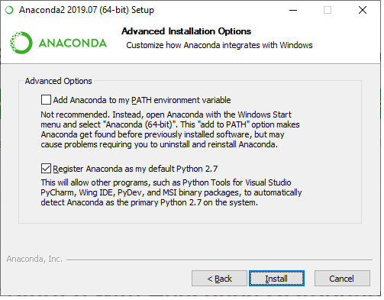

Click on "**Install**."

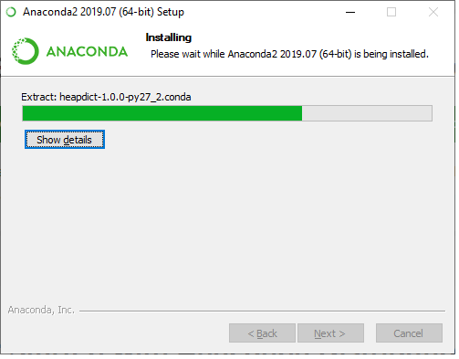

Click on "**Next**."



Click on "**Next**."



Click on "**Next**."



After clicking on "**finish**."

It will successfully installed in our system.

After that, we have to run the given command to set-up the TensorFlow and libraries.

1. Conda create -n tensorflow pip python.

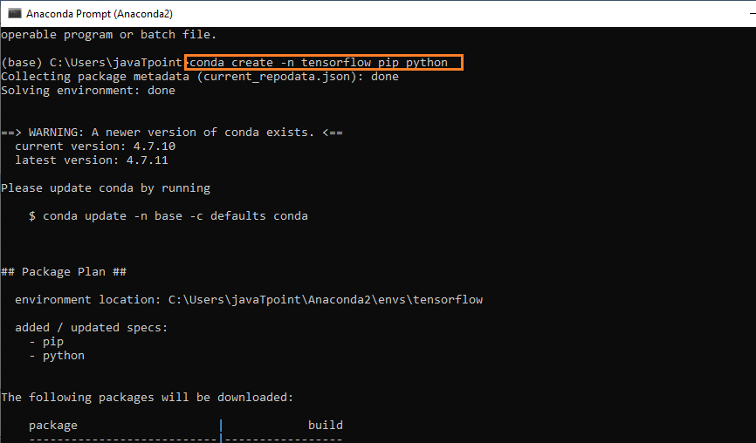

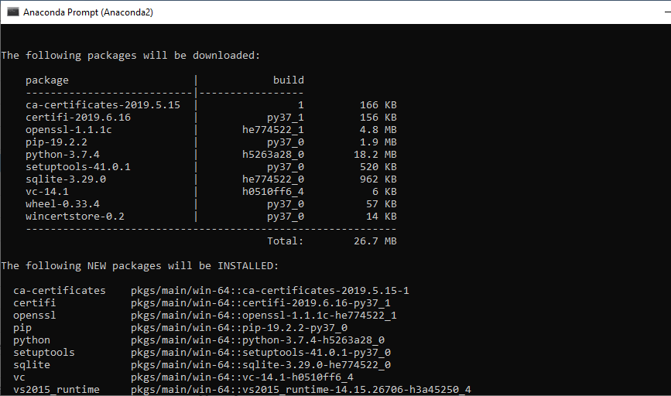

Here, we are downloading and installing the essential things which are used in **TensorFlow** to work.

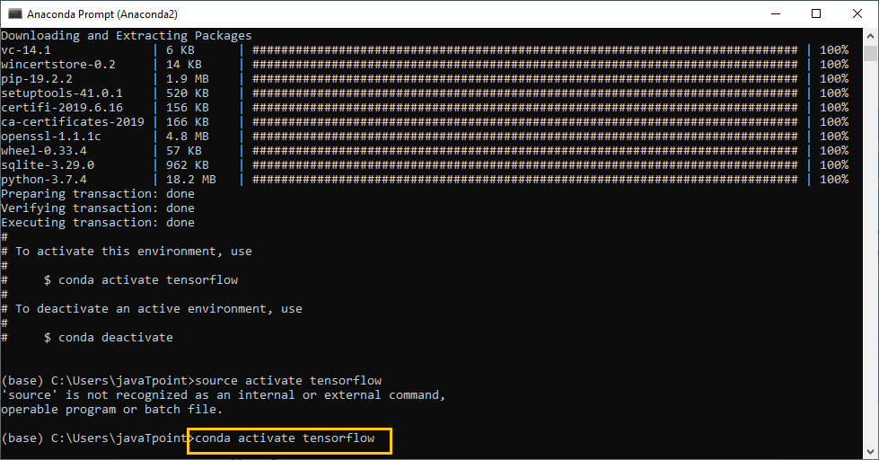

After that, we have to check that TensorFlow is working or not in our system.

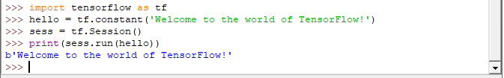

So, according to the above screenshot, TensorFlow is successfully working in our system.

**Result/Observations/Screenshots:**

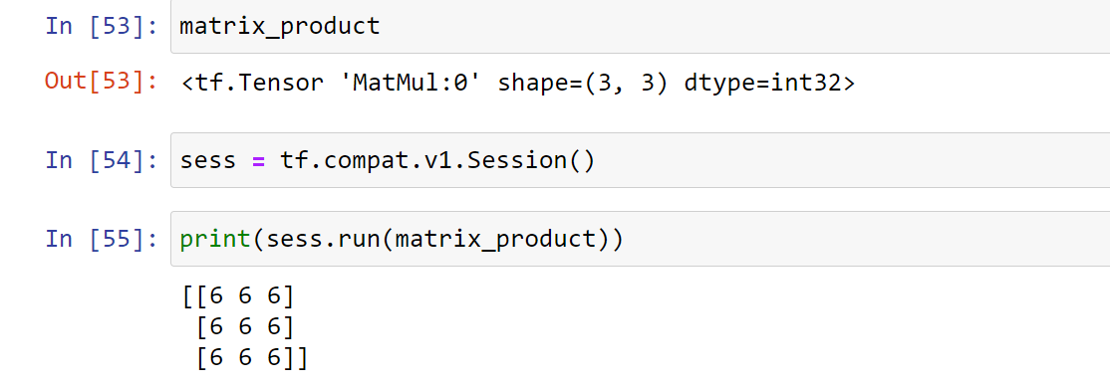

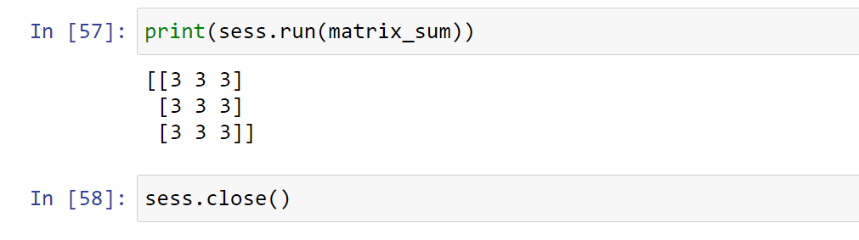

**Conclusion:**

Tensorflow uses graph implementation for numerical operations. It can train and run deep neural networks for image recognition, handwritten digit classification, recurrent neural network, word embedding, natural language processing, video detection, and many more. TensorFlow is run on multiple CPUs or GPUs and also mobile operating systems.

**References:**

* <https://www.tensorflow.org/tutorials>
* <https://towardsdatascience.com/the-complete-tensorflow-tutorial-for-newbies-dc3acc1310f8>
* <https://towardsdatascience.com/beginners-guide-to-deep-learning-with-tensorflow-ca85969b2f2>